EXP 17: Implementing CDMA Encoding/Decoding using MATLAB or Python
AIM
To simulate the encoding, transmission, and decoding of multiple users in a CDMA system using orthogonal Walsh codes and demonstrate how despreading recovers the original bits.

THEORY (Short & Clear)
1. CDMA (Code Division Multiple Access)
- Multiple users share the same channel at the same time.
- Separation is achieved using orthogonal spreading codes.
2. Walsh Codes
- Set of perfectly orthogonal binary sequences.
- Used to spread data bits, increasing chip rate.
3. CDMA Encoding
$$s=b×c$$
- Each user bit is multiplied by its Walsh code.
4. CDMA Decoding
Despreading is done by correlating the received signal with each user’s code:
$$d=∑(r⋅c)$$
- Positive result → bit = +1
- Negative result → bit = –1

PROCEDURE (Exactly 6 Lines)
- Assign BPSK data bits to the users.
- Select orthogonal Walsh codes for User 1 and User 2.
- Encode each user’s bit by multiplying it with its spreading code.
- Add (superimpose) both spread signals to simulate the CDMA channel.
- Recover each user’s bit by correlating the received signal with the corresponding code.
- Apply sign decision and plot codes, encoded signals, combined signal, and despread results.

PSEUDO CODE
START
DEFINE user bits b1 and b2
DEFINE orthogonal Walsh codes c1 and c2
COMPUTE s1 = b1 * c1
COMPUTE s2 = b2 * c2
COMPUTE received r = s1 + s2
DECODE d1 = sign(sum(r * c1))
DECODE d2 = sign(sum(r * c2))
PLOT codes, encoded signals, combined signal, and despread outputs
END
Code:
clear; clc; close all;

%% 1. Data bits for two users (BPSK format)
b1 = 1; % User 1 bit
b2 = -1; % User 2 bit

%% 2. Orthogonal Walsh codes (length-4)
c1 = [1 1 1 1]; % User 1 code
c2 = [1 -1 1 -1]; % User 2 code

%% 3. CDMA Encoding (spreading)
s1 = b1 * c1; % Encoded signal of User 1
s2 = b2 * c2; % Encoded signal of User 2

%% 4. Channel: signals add (superposition)
r = s1 + s2;

%% 5. CDMA Decoding (despreading)
d1 = sum(r .* c1); % Correlation with User 1 code
d2 = sum(r .* c2); % Correlation with User 2 code

d1_bit = sign(d1); % Decision for User 1
d2_bit = sign(d2); % Decision for User 2

disp('Decoded Bits:');
fprintf('User 1: %d | User 2: %d\n', d1_bit, d2_bit);

%% 6. Plot Results
figure;

subplot(4,1,1);
stem(c1,'filled'); hold on; stem(c2,'filled','r');
title('Walsh Codes of User 1 & User 2'); grid on;

subplot(4,1,2);
stem(s1,'filled'); hold on; stem(s2,'filled','r');
title('Encoded (Spread) Signals'); grid on;

subplot(4,1,3);
stem(r,'filled');
title('Combined CDMA Signal (Superposition)'); grid on;

subplot(4,1,4);
stem(r.*c1,'filled'); hold on; stem(r.*c2,'filled','r');
title('Despread Signals (Before Decision)'); grid on;
xlabel('Chip Index');

output:
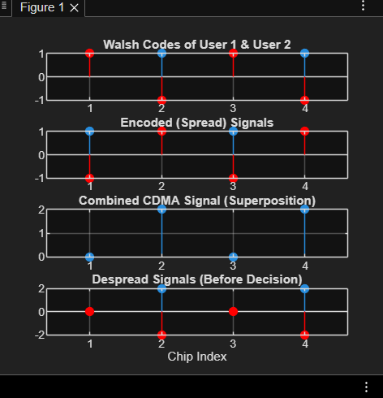

Conclusion:
CONCLUSION
- CDMA allows users to transmit simultaneously by assigning unique orthogonal codes.
- Even when signals overlap in the channel, despreading with the correct code successfully extracts each user's bit.
- The simulation clearly shows that Walsh codes maintain orthogonality, enabling interference-free decoding.
- CDMA is robust and supports multiple-access communication efficiently.

